Documentation on the Roads to Riva Process
March 18, 2020

Purpose: Each year, HRM owned street information is pushed to the RIVA application to allow Captial & Asset Management group in Finance to identify which streets have been acquired during the year, and which have been retired or altered. In addition, RIVA stores a financial value on the street based on it’s construction date and the street classification (local, collector, etc).

The TRN_STREET_RIVA in the GIS RW database table acts as a staging table and there is a script that runs nightly that will push any changes to the RIVA application.

This process is executed when a request from Finance is received. Sunil Sharan has been the business contact for the past number of years.

Initial Step – Start an ArcMap session and add the following inputs from GIS SDE:

  - TRN_street
  - TRN_STREET_RIVA
  - TRN_street_retired

Create a new version called “Roads2Riva_date”. Switch to new version and start an edit session.

**Before doing any edits, save a copy of TRN_STREET_RIVA to a file geodatabase just in case something goes wrong and the original data needs to be restored.

Step 1 - Determine what new streets have been added to TRN_street that do not exist in TRN_STREET_RIVA:

  - Select from TRN_street all records where OWN = HRM.
    - Save selection set to a new line feature class called TRN_street_HRMowned (create a new file geodatabase to temporarily store new fcs)
      - Add to ArcMap document
  - Create a relate between TRN_STREET_RIVA and TRN_street_HRMowned using FDMID as common field
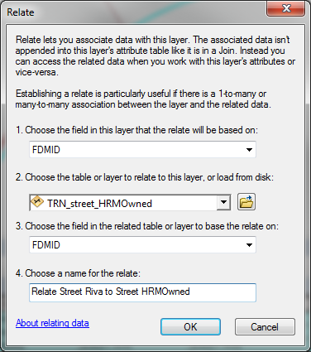

  - Select in TRN_STREET_RIVA all records
  - Remove from current selection all records where DATE_RET IS NOT NULL
  - Relate to TRN_street_HRMOwned
    - Switch the selection set in TRN_street_HRMOwned
    - Save Selection set in TRN_street_HRMOwned to a new line feature class called TRN_street_new_streets_riva
      - Add to ArcMap document
    - Open the attribute table for the TRN_street_new_streets_riva
    - Select all records
    - Export records to a table in the file geodatabase called TBL_new_streets_for_riva
      - Add to ArcMap document
  - Start an edit session.
    - Using the search window, open the Append (Data Management) Tool

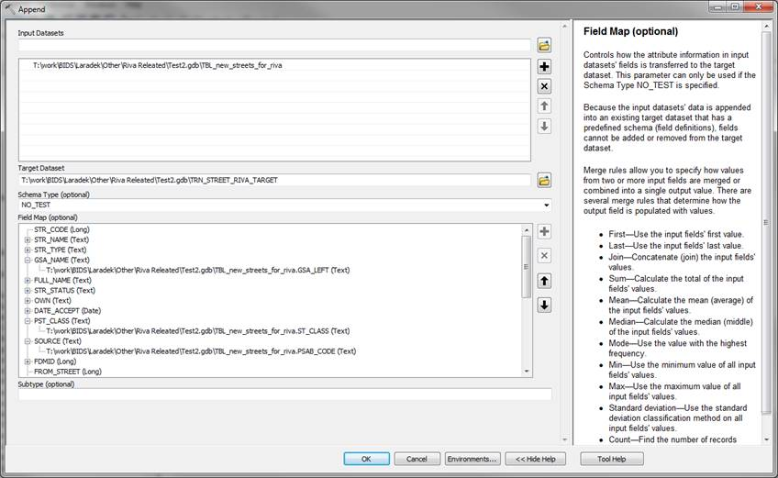

  - The input dataset will be TBL_new_streets_for_riva
  - The target dataset will be TRN_STREET_RIVA
  - Select No Test for Schema Type
  - Use the following table to update the field mapping section of the tool:
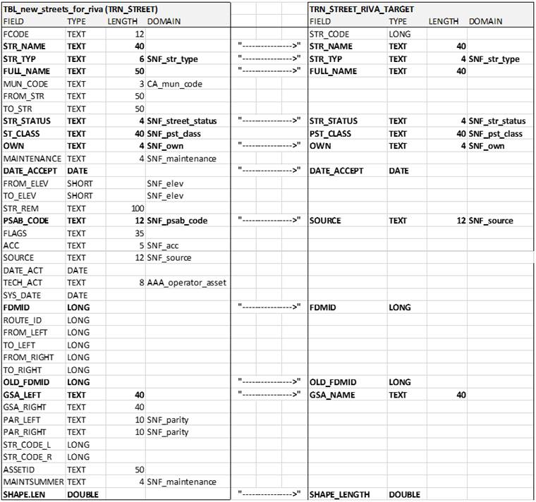

  - Select okay on tool, and the new streets will be appended into the TRN_STREET_RIVA (version).

Step 2 - Updating records in TRN_STREET_RIVA that have been retired and are now archived in TRN_street_retired:

  - Open the ArcMap document used in previous step.
  - Create a relate between TRN_STREET_RIVA and TRN_street using FDMID as common attribute
  - 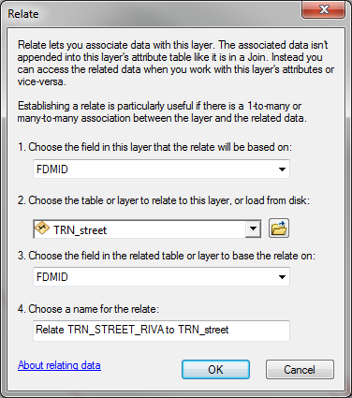

  - Create a relate between TRN_street_riva and TRN_street_retired using FDMID as common attribute

  - 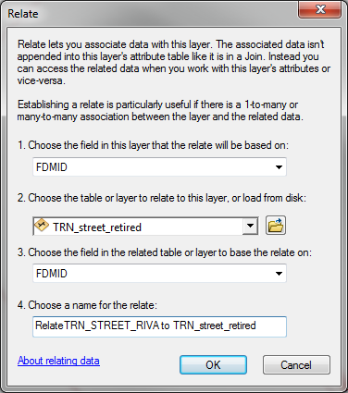

  - Select all records in TRN_street and relate to TRN_street_riva
  - Reverse selection set in the TRN_street_riva table
  - In the TRN_street_riva table, remove from selection set records that meet the following condition: DATE IS NOT NULL

  - 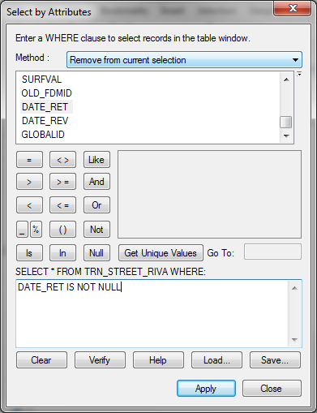

  - If no records remain, this means there are no new retired streets that need to be updated in the TRN_STREET_RIVA table. If there are records meet selection query, continue with next step.

  - Relate the selection set in TRN_street_riva to TRN_street_retired
  - Save selection set to a new line feature class called TRN_street_new_retired_streets_riva
    - Do this by right clicking on TRN_street_retired in the Table of Contents and choose Data --> Export Data
  - Add the new feature class to the ArcMap document.
  - This out put will be joined to the TRN_street_riva table, to update the DATE_RET field, shape.length, and anything else.
  - Create a join between the TRN_STREET_RIVA and TRN_street_new_retired_streets_riva using FDMID as common attribute, and only keep the matching records.
  - Start an edit session
  - Update the following attributes using the Field Calculator tool (right-clicking on attribute field column heading)

1 | TRN_STREET_RIVA.DATE_RET = TRN_street_new_retired_streets_riva.DATE_RET
2 | TRN_STREET_RIVA.DATE_REV = Today's Date
3 | TRN_STREET_RIVA.OLD_FDMID = TRN_street_new_retired_streets_riva.OLD_FDMID
4 | TRN_STREET_RIVA.shape_length = TRN_street_new_retired_streets_riva.shape_length
  - Save Edits
  - Stop editing
  - Remove join

Step 3 Updating existing segments to reflect any changes in length, to and from street.

  - Create a join between TRN_STREET_RIVA and TRN_street using FDMID as common attribute, and only keep matching records
  - Select all records in TRN_street_riva
  - Remove from Selection set records where TRN_street_riva.ret_date IS NOT NULL.
  - Remove from selection records where TRN_street_riva.shape.length = TRN_street.shape.length (Seems that this can only be done when using a copy of TRN_street that has been saved to a FGDB)
    - Note - It is rare to have segments length match, it is normal for all segments to have the following calcs done..
  - Start an edit session
  - For remaining records, update based on the following calculations:
    - Update TRN_street_riva to equal the shape.length in TRN_street
      - ** create a table of TRN_street to calc lengths
    - Update the Short_Desc and Long_Desc in TRN_street_riva - Use the following logic statement:
      - Short_Desc:
[SDEADM.TRN_street.FULL_NAME] + " (" + [SDEADM.TRN_street.FROM_STR] + " TO " + [SDEADM.TRN_street.TO_STR] + ")"
  - Long Desc:
[SDEADM.TRN_street.FULL_NAME] + " (" + [SDEADM.TRN_street.GSA_LEFT] + ")"
  - Update the OLD_FDMID field to equal OLD_FDMID in TRN_street
  - Update the DATE_REV in TRN_street_riva for records updated
  - Save edits
  - Stop editing
  - Remove join
  - Do a quick visual check before reconciling and posting to Default

Python 3: This will work, but will skip over any records with null values. I ended doing the concatenation in excel and creating a new table to join the riva table with.

!TRN_street_02Mar2022.FULL_NAME! + " (" + !TRN_street_02Mar2022.FROM_STR! + " TO" + !TRN_street_02Mar2022.TO_STR! + ")"

!TRN_street_02Mar2022.FULL_NAME! + " (" + !TRN_street_02Mar2022.GSA_LEFT! + ")"

